**1**

**Problem Statement**

Without a Problem we can't get any inventions. Inventions are based on problems which we are faced in our daily life. Here we Take one problem in our day to day life

and represent our ides.

**10 minutes**

**2**

**Brainstorm**

By understanding our problem statement some Ideas that come to my mind that address our problem statement.

**10 minutes**

**3**

**Brainstorm Group ideas**

Take turns sharing your ideas while clustering similar or related notes as you go. Once all sticky notes have been grouped, give each cluster a sentence-like label. If a cluster is bigger than six sticky notes, try and see if you and break it up into smaller sub-groups.

**15 minutes**

**4**

**Prioritize**

Priorities given to our project by time.

**5 minutes**

**Brainstorm**

**& Idea Prioritization**

Here we use this template to represent our problem statement and give our ides to

Fire Detection Systems are now widely used in various safety and security applications. The major amount of fires tarts due to the electric short circuit.It leads to damage to property and also loss of life. To avoid that or to minimize the damage caused by fire outbreaks due to electric short circuits an IoTtechnology is used to control such a kind risk.

**Preventive Measures**

Sending alert text message about the

fire to the user along with onsite alarms

Transferring

messages through wireless

Provision of clear signage indicating exist routs and location of fire safety equipments

Fire alarms tested and maintained periodically

Storage of flammable materials in a safe area

Regular fire and evacuation drills

Updating temperature, humidity, and smoke on IBM cloud platform at periodic intervals

Installing automated chamber locking

Early detection using smoke sensor

Importance

If each of these tasks could get done without any difficulty or cost,

which would have the most positive impact

Feasibility

Regardless of their importance, which tasks are more feasible than others (Cost, time, effort, complexity, etc.)

prevent that. It gives workers to be work in trustable field. It helps to save so many peoples, workers, students and others life from fire Accidents.

Traditional fire detection systems are not that effective and quick to alert the owner about fire, in case no one is present on the location. To overcome this problem in this paper we present the design and development of IoT based Fire Detection System. A system that combines qualities for fire, temperature and smoke detection, sendingalert Text Message about the fire to the user along with onsite alarm(buzzer), updating temperature, humidity and smoke on ThingSpeak cloud every 15seconds, and it also moves manually with the help of Android Application. The Fire Detection System consists of four main parts: Multiple sensors, communication system (Bluetooth, GSM, NodeMCU), motion planning (Manual patrolling), and Android application for manual patrolling of the system. This Fire Detection system can be used in

Systematic approach for monitoring and control

Storage area equipped with a sprinkler and asmoke alarm

To get real life data using IOT technology

Python code for publishing random sensor

data

D Davin jegath sony

Sending alert text message about the

fire to the user along with onsite alarms

Electrical fittings must be properly maintained

To provide a low cost fire alarm system

MAKE SPECIAL ROOM FOR FIRE MANAGEMENMT

Sereena jerry

**Maintenance**

Storage of flammable materials in a safe area

Maintenance of the

emergency lighting

Water tank with separate piping with hose reel to

all the floors

Electrical fittings must be properly maintained

Fire alarms tested and maintained periodically

Implementing adequate number

of fire

extinguishers in each block

Maintenance of the emergency lighting

Creating an Webapp to monitor the temperature, gas and Flame

Emergency alerts are notified to

fire station and authorities

Using Fire retardant materials for interior design

technologies

Transferring messages through wireless techonolgies

**Applications**

Updating temperature, humidity, and smoke

on IBM cloud platform at periodic intervals

Create node red flow to get data from devices

To get real life data using IOT technology

A web page created to

analyze the data and response extract

conditionaly to launch

water sprinklers

Android application for manual patrolling

of the system

Create node red flow to get data from devices

Software deigned

to with stand harsh industrial conditions

Android application for manual patrolling

of the system

Systematic approach for monitoring

Electrical fittings must be properly maintained

Systematic approach for monitoring

To provide a low cost fire alarm system

If flame is detected sprinklers

Existence of emergency population warning methods

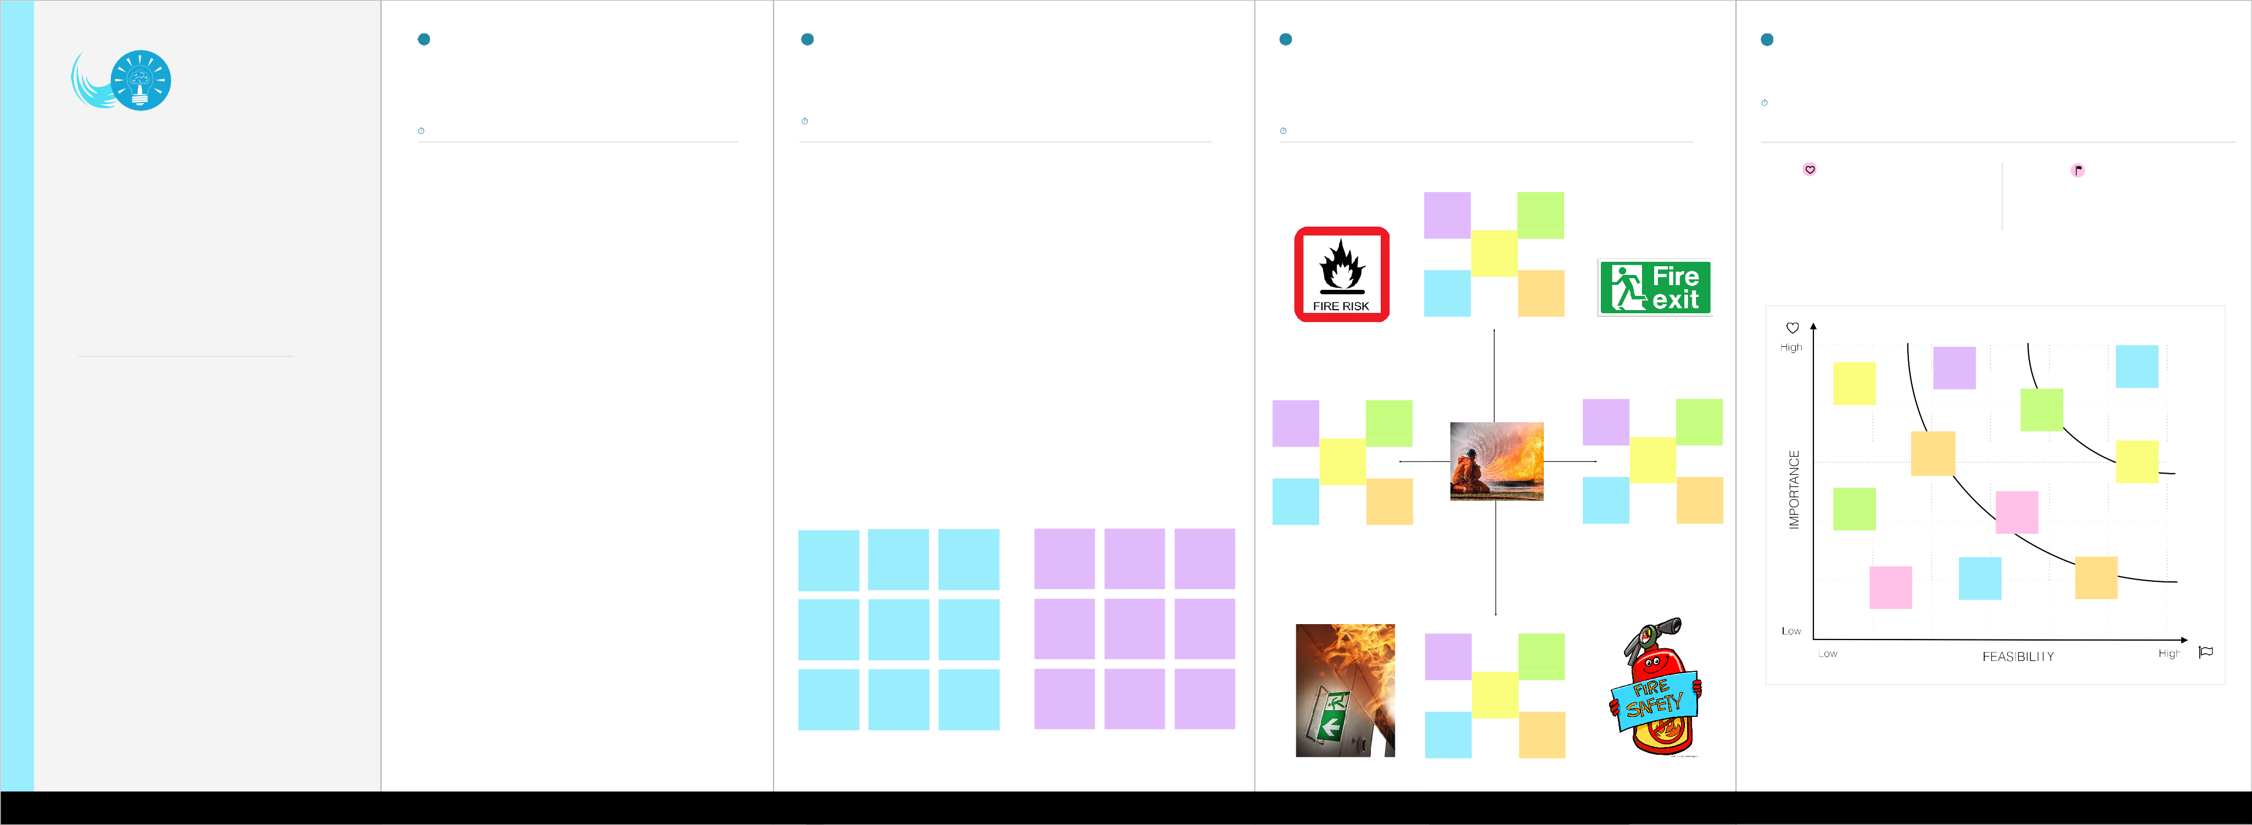

A Akil sashya

A K Arul diksha

Create node red flow to get data from devices

Usage of Gas Detection system

transferring

messages through wireless technologies

Creating an Emergency fre exit

Android application for manual patrolling

of the system

Put up signs and

contact information for emergencies

If flame is detected sprinklers

will be switched on automatically

Implementing adequate number

of fire extinguishers in each block

Provision of clear signage indicating exist routs and location of fire safety equipments

Multi sensors are used to detect any changes in the environment

PERSONAL EMERGENCY EVACUATION PLAN

Software deigned

to with stand harsh industrial conditions

USE SPECIAL BLANKET FOR INSTANT

FIRE

Cloudant DB nodes to store

the recieved sensor data

Water tank with separate piping with hose reel to

all the floors

If any gases are present the exist fans are powered

on

A web page created to

analyze the data and response extract conditionaly to launch water sprinklers

**Advantages**

To provide a low cost fire alarmsystem

Connects multiple bulidings

Existence of emergency population warning methods

Existence of emergency population warning methods

Gives Workers to a trustable place

Python code for publishing random sensor

data

Android application for manual patrolling

of the system

Electrical fittings must be properly maintained